1 Hour and 30 minutes

THE UNIVERSITY OF MANCHESTER

EART26201 Principles of Geochemistry

?? January 2024

Time: ??:?? - ??:??

Answer ALL questions in the booklets provided.
Clearly label which question each of your answers corresponds to. All writing must be LEGIBLE. Illegible documents cannot be marked.
There are 100 marks available on this paper. The number of marks for each question is shown and may be used as a guide to how much time you should spend on each.
You may wish to use labelled sketches to illustrate your answers where appropriate.
The use of calculators is permitted, as long as they cannot store text, perform algebra and have no graphing capability.

© The University of Manchester, 2023

Question 1
- The crystallisation behaviour of mantle melts can be summarised using a phase diagram of the forsterite (Fo; Mg₂SiO₄)-quartz (Qz; SiO₂) system. Cristobalite (Cr) is a high-temperature polymorph of SiO₂; quartz is a low-temperature polymorph. Enstatite (En) has an intermediate composition between Fo and Qz.
Quantitatively describe the equilibrium crystallisation of a mantle melt analogue with a composition of Fo₈₀Qz₂₀ from 1900 to 1500 °C. [15%]
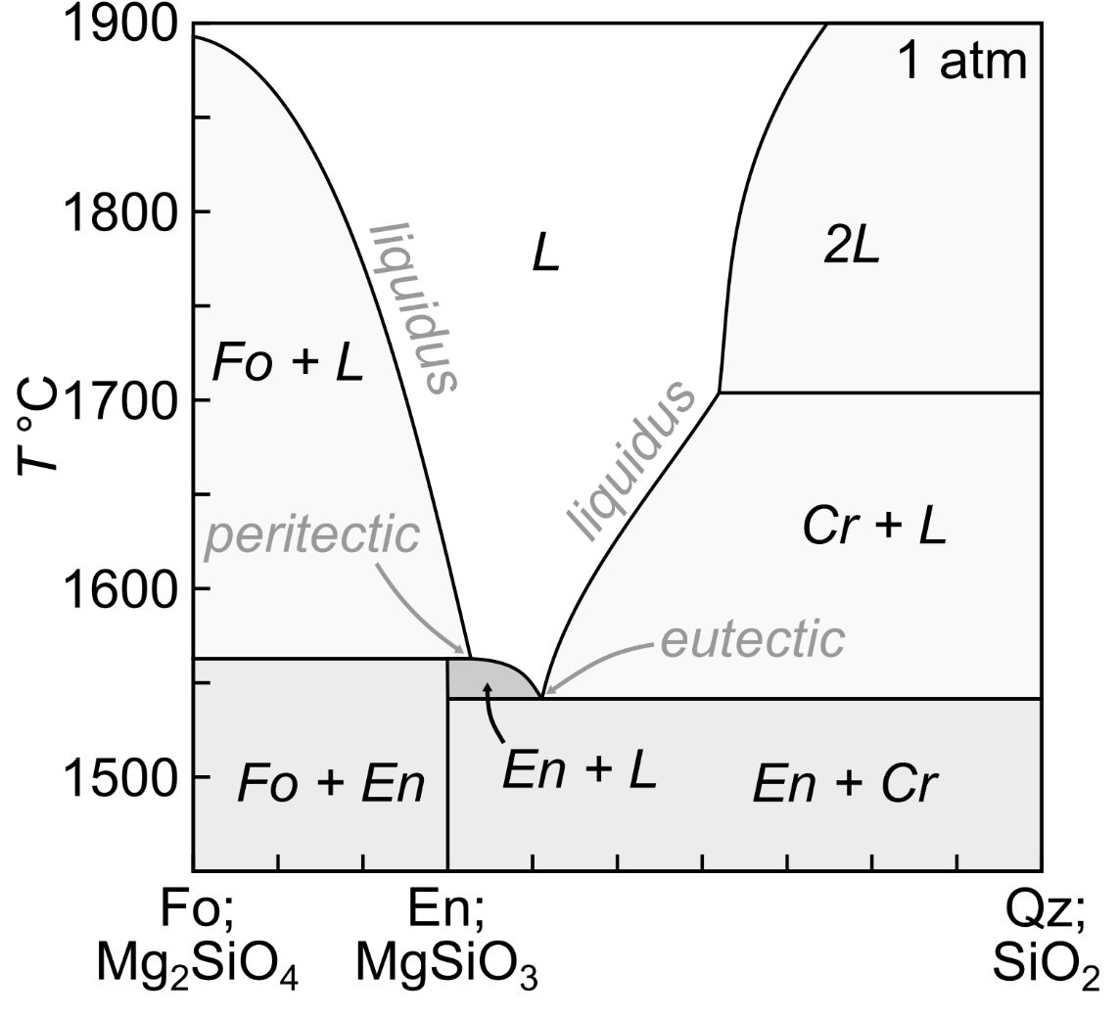
Once the melt cools to ~1750°C Fo will start to form. Crystallisation will then continue, with the melt becoming progressively richer in Qz; the composition of the Fo will remain unchanged. At ~1570°C, the liquid will reach the peritectic, defined by the reaction Fo + L = Qz. At this point the liquid will have the composition Fo₆₈Qz₃₂. Because the system is evolving by equilibrium crystallisation, Fo will be consumed by the peritectic reaction to produce En. Because the melt has a lower Qz content then En, the peritectic reaction will stop once the melt has been exhausted, leaving a solid containing Fo and En in proportions of 67% and 33%, respectively, which is compositionally equivalent to the composition of the initial melt.

- How and why would the end products of fractional crystallisation differ from the end-products of equilibrium crystallisation for the same composition (Fo₈₀Qz₂₀)?
If the system evolved by fractional crystallisation the peritectic reaction could not occur because there would be no Fo to react with the remaining melt. The liquid composition would thus continue to evolve from ~1570 °C to ~1540 °C by En crystallisation until the eutectic defined by the reaction En + Qz = L, where the last solid would eventually form with solid containing En and Qz in proportions of ~84% and ~16%, respectively.
- Mantle-derived primitive melts may contain ~200 ppm Ni and ~1 ppm Nb, and crystallise olivine on their way to the surface. Using the Rayleigh fractionation equation given below, calculate how the composition of a mantle-derived primitive melt will evolve in response to 20%, 40% and 80% fractional crystallisation of olivine. Use olivine-melt partition coefficients of 10 and 0.001 for Ni and Nb, respectively. The Rayleigh fractionation equation is as follows:
$$\frac{C_{l}^{melt}}{C_{0}^{melt}}=F^{\left(D-1\right)}$$
where $C_{o}^{melt}$ is the concentration of a given element in a primitive melt, $C_{l}^{melt}$ is the concentration of a given element in an evolved melt, $D$ is the crystal-melt partition coefficient for a given element, and $F$ is the melt fraction remaining (0 = melt remaining, 1 = all melt remaining) [10%]
% Crystallisation | Ni (ppm) | Nb (ppm)
20% | 26.84 | 1.25
40% | 2.02 | 1.67
80% | 0.0001 | 4.99
- Qualitatively explain how much crystallisation is required for melts to form economic deposits of Ni and Nb, respectively? [5%]
Ni is compatible in olivine and is therefore rapidly removed by fractional crystallisation. Ni deposits must from mantle-derived melts that have not experienced significant fractional crystallisation. Conversely, Nb is incompatible in olivine and is therefore concentrated by fractional crystallisation. Nb deposits must from mantle-derived melts that have experienced significant fractional crystallisation.

- How can radiogenic isotopes be used to determine the absolute ages of ancient volcanic rocks? What are the limitations of using radiogenic isotopes for dating? Use sketches and examples of radiogenic isotope systems to illustrate your answers as appropriate [15%]
Absolute ages of ancient rocks from isochron dating in which ratios of parent to stable isotopes are plotted against ratios of daughter to stable isotopes such that samples with different amounts of the parent isotope evolve over time to produce more of the daughter isotopes. The different ratios of parent to stable isotopes result from partitioning differences during the formation of the rock, with different mineral hosting different proportions of the parent and daughter/stable isotopes. Assuming that the samples were in isotopic equilibrium at the time of formation and the system has remained closed (no resetting or weathering), the slope of a line fitted to the isotopic composition of the samples is related to their age via the decay constant for the system; the intercept gives the initial daughter to stable isotope ratio. This line itself is called an isochron and gets progressively steeper as time passes. As well as showing a sketch of an isochron diagram, students may refer to key systems that have been discussed in detail such as Rb-Sr or Sm-Nd.
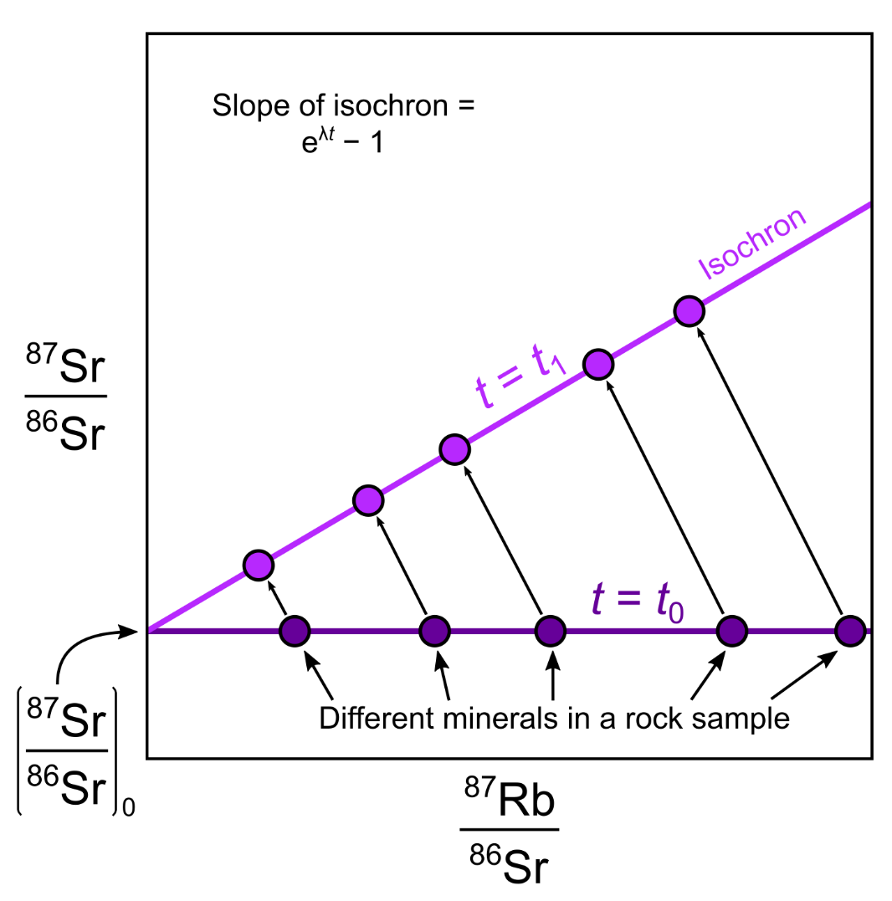

Question 2
Water flowing from a fault contains 10.0 mmol (millimoles) of sulphuric acid and 50mmol of sulphate ions in solution. The Ka of sulphuric acid is 1x10⁻³. Using the Henderson Hasselbalch equation:
$$pH=pKa+log\left(\frac{A^{-}}{HA}\right)⁡$$

(a) Calculate the pH [20 marks]

Answer:
pH = pKa + log (sulphate/ H2SO4)
pH = -log (1 x 10-3) + log (50 M / 10 M)
pH = -log (1 x 10-3) + log (5)
pH = 3 + 0.7
pH = 3.7

(b) The pE of the water discharging from the fault has been measured at 7.5. Using the pE/PH diagram for the Fe-H-O system provided, predict 1) the oxidation state of iron dissolved in this water and 2) the composition of any solid phases that might precipitate as the water from the fault mixes with surface fluids. [5%]
(c) Would you expect precipitation to be instantaneous? Explain your answer [5%]

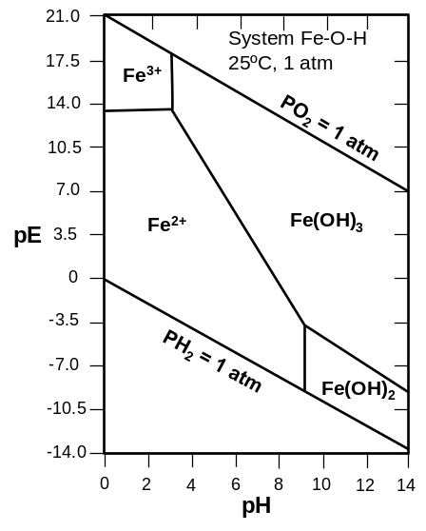

(b) Answer: Fe2+ with Fe(OH)3 precipitate
(c) No – kinetics.

Question 3
Explain the following and briefly discuss their importance for natural surface/subsurface fluids (a) pH (b) alkalinity; (c) Ion activity product and solubility product and (d) pE. [20 marks]

Answer:
pH = -log(H+). So low pH is high H+ is acidic therefore promotes mineral dissolution.

Alkalinity is ability to accept protons therefore capacity to neutralise or buffer a solution therefore important in many natural systems e.g ocean pH.

IAP > or < Ksp determines if a solution os super or undersaturated with respect to specific ions.

pE is analogous to pH ie -log(e-). ‘Explaining the importance’ in this section is quite open to interpretation – anything relevant will get credit.

END OF EXAMINATION PAPER

Document tracking sign off table

Please fill out form at each stage of process so the process can be tracked

Stage | Role | Name | Signature | Date
1. Question setting | UC
2. Internal Review | IM
3. Address Internal review | UC
4. External Examiner review | EE
5. Address external review | UC
6. Final check of print out | UC
UC = unit coordinator; IM = internal moderator; EE = External examiner.

